Get me IP address of particular domain (guvi.in) How do I find my CPU/memory usage of my server? Test the connectivity between 2 nodes? I have deployed an application in guvi.com:9000, and logs shows my app is running, but I’m unable to view the page. Check whether my port is open or not ?

To get the IP address of particular domain guvi.in

nslookup guvi.in

host guvi.in

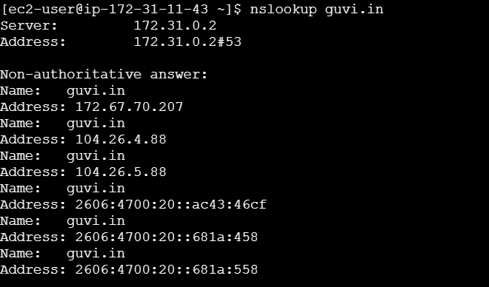

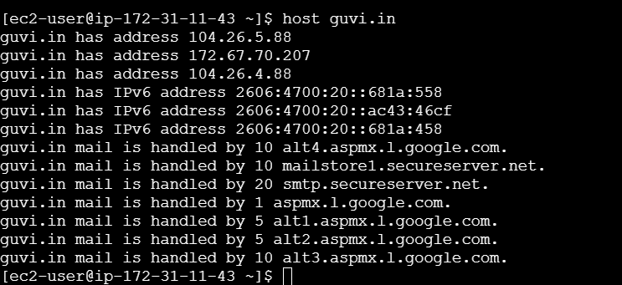

Top command- displays the real time process information including CPU usage and memory usage

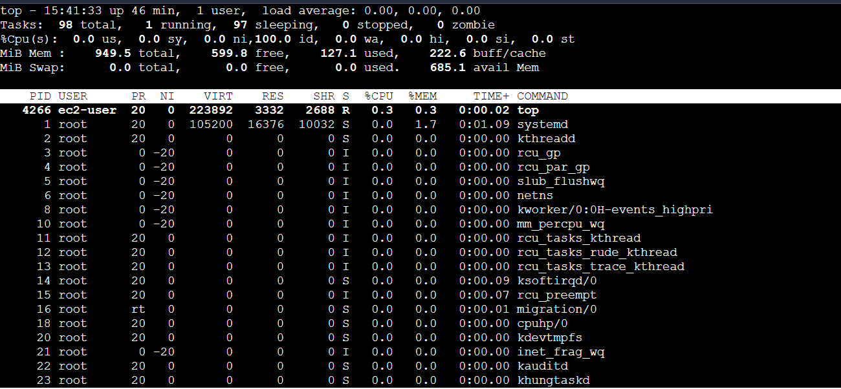

To test the connectivity between 2 nodes

ping guvi,in

This command sends ICMP echo requests to guvi DNS server and displays the response time

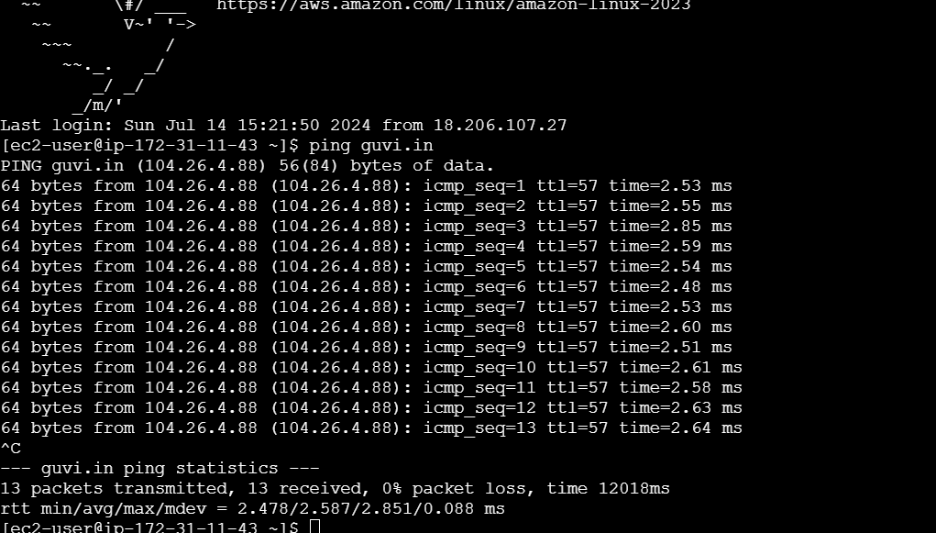

To check if the port is opened or not

telnet <host_IP_address><port_number>

if the port is open, you will see a connection established message. If it is closed you will see a connection refused message.